Project Documentation

This is the explanation for the options Project I want to create. The aim of this project is being able to screen the options strategies and let the app suggest which is the best combination within the selected strategy and ticker.

You can find the project hosted in GitHub

<https://github.com/inigoperezu/optionscreener>

**Idea**

The goal is creating a web app able to display option strategies following the ticker, expiration dates and strikes desired by the user. The second functionality is making the app to display which is the best strike combination in terms of risk to reward ratio.

**Idea layout**

TITLE

5

43

2

33

1

1.- List of the available strategies to choose

2.- Input the information

The ticker will be a text field

The dates will be selectable from the available dates

The strikes will be selectable from the available strikes

3.- Relevant data of the selected strategy

4.- Comparison of selected input and maximized data computed by the app

5.- Graph plot of the selected strategy

**Process**

The project needs two separated codes. On the one side I have to write the app (Layout) and on the other side the components.

For the app I will use dash, by plotly that allows to display the program in a web browser and is very user friendly even though the layout is not defined. For the component I will use jupyter notebooks because is and allows the user to separate the components and edit them in a very visual way.

The libraries used are:

* Yahoo finance
* Pandas
* Dash
* Plotly
* Numpy

**Current status of the project**

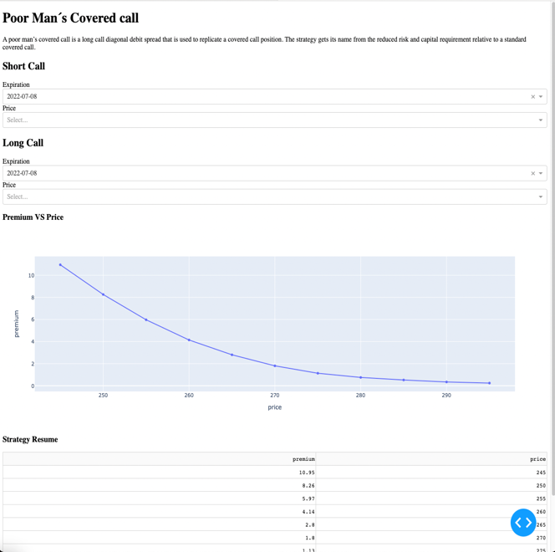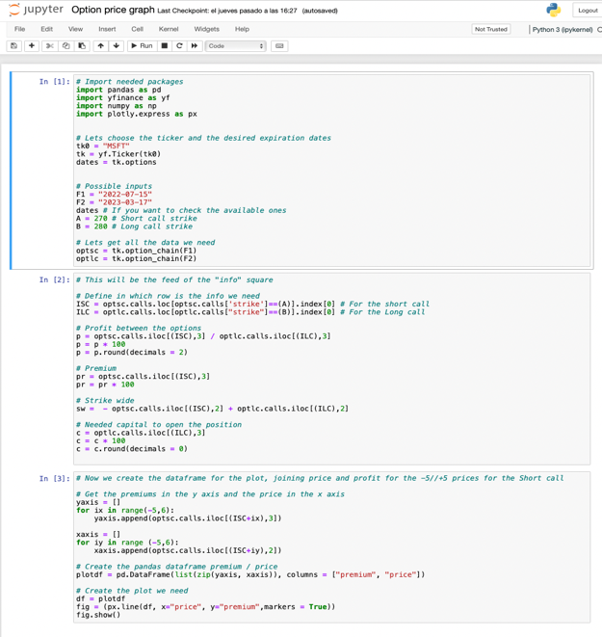

On the left part is the skeleton of the app, although the data is real, I only need to interconnect the components between them and modify the layout.

On the right is the jupyter notebook I am currently using to create the components. For each strategy I will create a separated one to be able to have viable parts and make sure they work or if needed modify them easily.

**Next steps and ideas**

The next steps are:

In the side of the dashboard, connecting all the callbacks of the components to make them communicate and let the user use the app, providing that right now is “hard code”.

Apart from this is necessary start working in the layout to be able to organize the strategies. Will be done first of all in hard code, and the I will populate the layout with functional components.

On the other side, the components one, I will develop components for other strategies based on the main points of each ones (depending on the characteristics of each strategy, the objective can be minimize risks, set a delta neutral position or hedge your own position)

Ideas:

* Create a button to get straightly the best combination.
* Make another section that can be “strategy comparison” In which the platform allows you to display two strategies.